**Department of Computer Science**

National University of Computer and Emerging Sciences

Lahore Campus

**Digital Logic Design**

**EE227**

**Section E & F**

**Assignment 2**

**Due Date 16th April 2021**

**Submit handwritten PDF document in Google Classroom.**

**No late submissions are allowed.**

**Question 1**

Simplify following combinational circuits using Boolean algebra identities and rules.

1. AB’C(BD + CDE) + AC’
2. AB’C + A’BC + A’ B’C
3. BCDE + BC(DE)’ + (BC)’DE

Draw both circuits and calculate gate input cost before and after simplification.

**(a)**

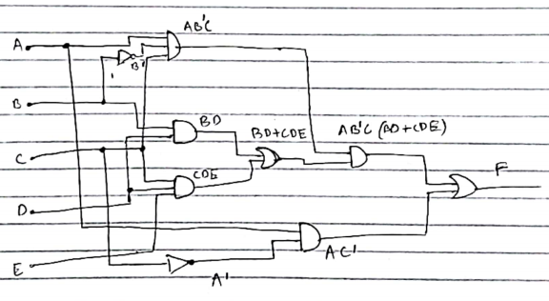

Gate input cost= G = (3 x 2) + (2 x 3) + (2 x 2)

= 16

GN= 16 + 2

As there are 2 AND gates of 3 inputs, 3 AND gates of 2 inputs, 2 OR gates of 2 inputs and 2 NOT gates.

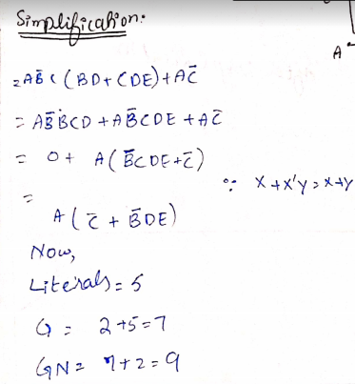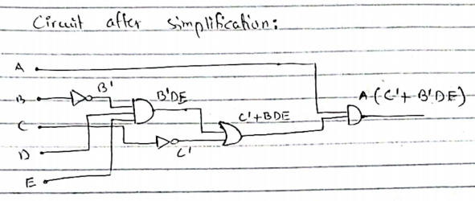

**(b)**

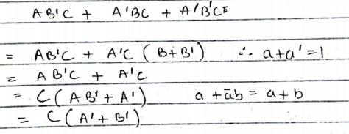

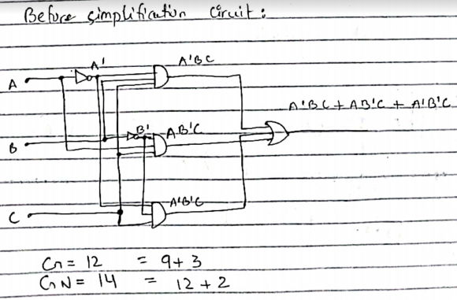

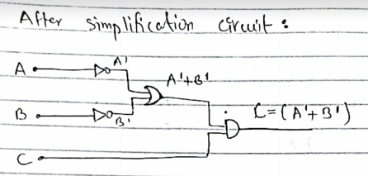

G= 4

GN= 4 + 2 = 6

**(c)**

**Same procedure as above parts**

**Book Morris Mano 5th edition**

**2.1 (c)**





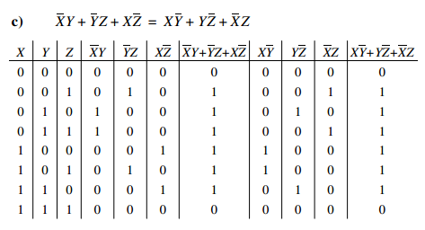

**2.2 (d)**





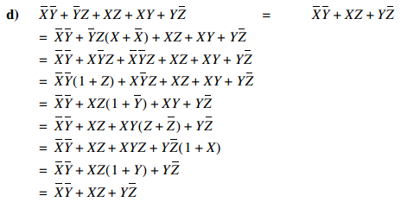

**2.3 (b)(c)**





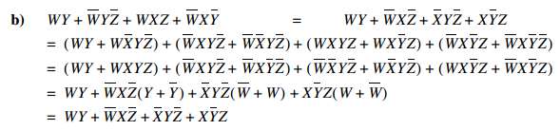



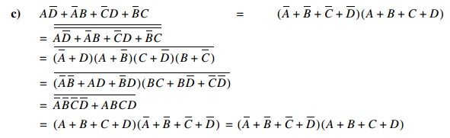

**2.6 (b)(d)**



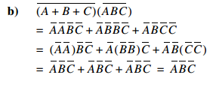



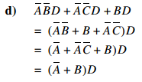

**2.7**

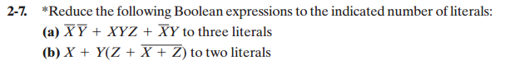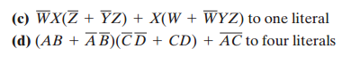

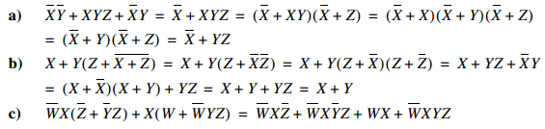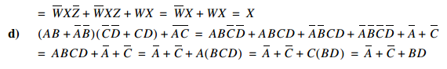

**2.12**

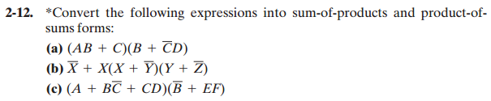

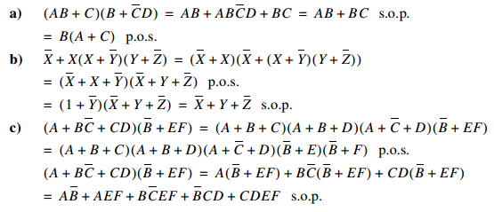

**2.14 (d)**



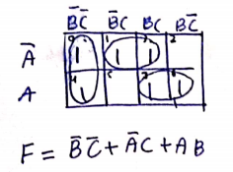

**2.15 (c)**



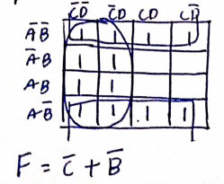

**2.17**

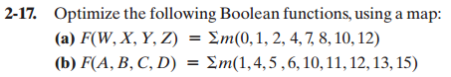

**(a)**

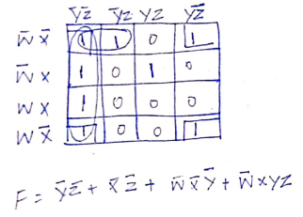

**(b)**

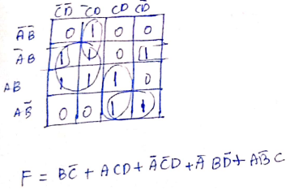

**2.18 (c)**





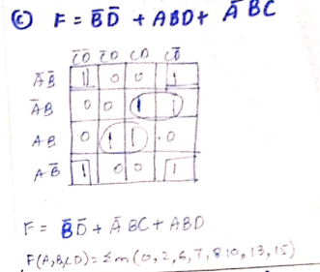

**2.22(c)**





**Sol 1:**

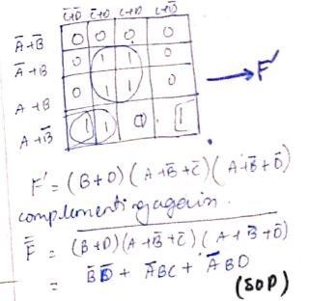

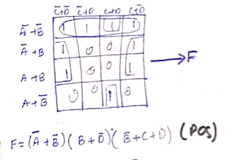

**Sol 2:**

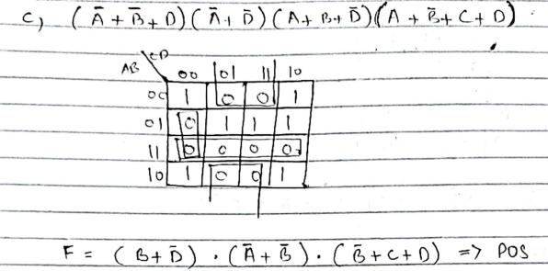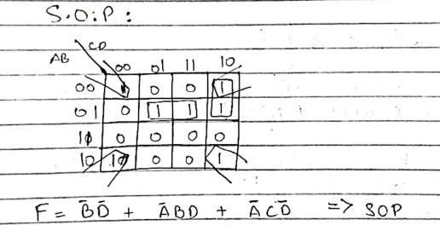



**2.23 (b)**





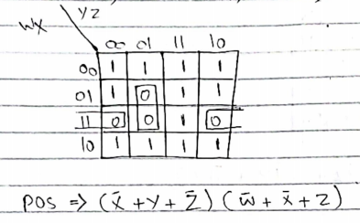

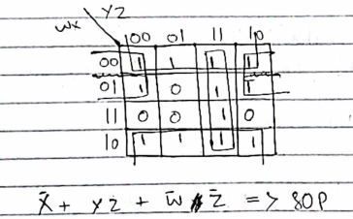



**2.24 (c)**





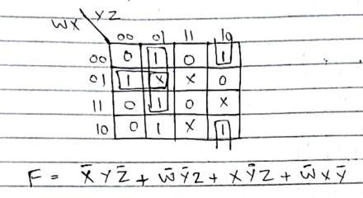

**2.26(b)**





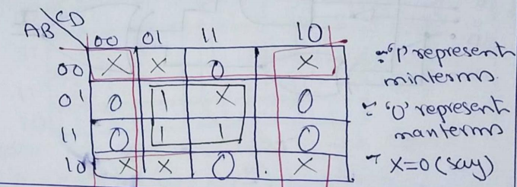

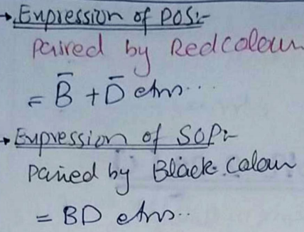

**2.28**



